1/1/2026

MPLS & VPLS Backbone Design based on Islington College Using GNS3 and MikroTik

MPLS & VPLS

**SUBASH SUBEDI**

Project@suashsubedi0.com.np

**Scenario**

Islington College operates a multi-block campus network consisting of 9 academic and administrative blocks. The college owns a public IPv4 address range (160.30.132.0/24), which must be used for router loopback interfaces within an MPLS backbone.

We are required to design, implement, and verify an MPLS-based core network using MikroTik routers in GNS3, providing VPLS-based Layer-2 connectivity across all blocks while using a centralized DHCP server.

The LONDON_BLOCK is the main block, connected to the Internet (ISP), and all other blocks connect to it directly and via additional mesh links for redundancy and load balancing.

**Network Architecture and IP Addressing Plan:**

Core Design

* All block routers act as MPLS core routers
* OSPF is the IGP across all routers
* MPLS with LDP must be enabled on all core and mesh links
* ECMP / Load balancing must be implemented
* VPLS must be used to extend VLANs across all blocks
* No DHCP service should run on any router

Use the following explicit IP addressing scheme. All loopback addresses are from the public IPv4 range 160.30.132.0/24 (160.30.132.0 to 160.30.132.255). Do not use any other IPs for loopbacks or links.

**Block Routers and Loopback IPs**

* LONDON_BLOCK (main block, connected to ISP): Loopback IP 160.30.132.1/32
* UK_BLOCK: Loopback IP 160.30.132.11/32
* NEPAL_BLOCK: Loopback IP 160.30.132.12/32
* HIMAL_BLOCK: Loopback IP 160.30.132.13/32
* BRIT_BLOCK: Loopback IP 160.30.132.14/32
* SKILL_BLOCK: Loopback IP 160.30.132.15/32
* ALUMNI_BLOCK: Loopback IP 160.30.132.16/32
* KUMARI _BLOCK: Loopback IP 160.30.132.17/32

**Point-to-Point Links from LONDON_BLOCK (Private IPs, /30 subnets):**

* LONDON_BLOCK to UK_BLOCK: 10.0.0.0/30 (LONDON_BLOCK: 10.0.0.1, UK_BLOCK: 10.0.0.2)
* LONDON_BLOCK to NEPAL_BLOCK: 10.0.0.4/30 (LONDON_BLOCK: 10.0.0.5, NEPAL_BLOCK: 10.0.0.6)
* LONDON_BLOCK to HIMAL_BLOCK: 10.0.0.8/30 (LONDON_BLOCK: 10.0.0.9, HIMAL_BLOCK: 10.0.0.10)
* LONDON_BLOCK to BRIT_BLOCK: 10.0.0.12/30 (LONDON_BLOCK: 10.0.0.13, BRIT_BLOCK: 10.0.0.14)
* LONDON_BLOCK to SKILL_BLOCK: 10.0.0.16/30 (LONDON_BLOCK: 10.0.0.17, SKILL_BLOCK: 10.0.0.18)
* LONDON_BLOCK to KUMARI_BLOCK: 10.0.0.20/30 (LONDON_BLOCK: 10.0.0.21, KUMARI_BLOCK: 10.0.0.22)
* LONDON_BLOCK to ALUMNI_BLOCK: 10.0.0.24/30 (LONDON_BLOCK: 10.0.0.25, ALUMNI_BLOCK: 10.0.0.26)

**Mesh Connections (Router-to-Router Private IPs, /30 subnets for redundancy):**

* UK_BLOCK to NEPAL_BLOCK: 10.0.0.28/30 (UK_BLOCK: 10.0.0.29, NEPAL_BLOCK: 10.0.0.30)
* UK_BLOCK to HIMAL_BLOCK: 10.0.0.32/30 (UK_BLOCK: 10.0.0.34, HIMAL_BLOCK: 10.0.0.33)
* NEPAL_BLOCK to BRIT_BLOCK: 10.0.0.36/30 (NEPAL_BLOCK: 10.0.0.37, BRIT_BLOCK: 10.0.0.38)
* HIMAL_BLOCK to SKILL_BLOCK: 10.0.0.40/30 (HIMAL_BLOCK: 10.0.0.42, SKILL_BLOCK: 10.0.0.41)
* BRIT_BLOCK to KUMARI_BLOCK: 10.0.0.44/30 (BRIT_BLOCK: 10.0.0.46, KUMARI_BLOCK: 10.0.0.45)
* SKILL_BLOCK to ALUMNI_BLOCK: 10.0.0.48/30 (SKILL_BLOCK: 10.0.0.50, ALUMNI_BLOCK: 10.0.0.49)
* ALUMNI_BLOCK to KUMARI_BLOCK: 10.0.0.52/30 (ALUMNI_BLOCK: 10.0.0.53, KUMARI_BLOCK: 10.0.0.54)

**VLANs and End-Device Subnets (Provided by Centralized DHCP):**

* VLAN 100 (STUDENT): 172.16.0.0/19 (capacity for 5,000 student IPs)
* VLAN 200 (TEACHER): 172.16.32.0/19 (capacity for 1,000 teacher IPs)
* VLAN 300 (STAFF): 172.16.36.0/21 (capacity for 2,000 staff IPs)

**Table of Contents**

1. Set Identity, Loopback Address and RoMON to all Routers 1

1.1. LONDON-BLOCK 1

1.2. UK-BLOCK 2

1.3. NEPAL-BLOCK 3

1.4. HIMAL-BLOCK 4

1.5. BRIT-BLOCK 5

1.6. SKILL-BLOCK 6

1.7. ALUMNI-BLOCK 6

1.8. KUMARI-BLOCK 7

2. Configuration IP in the Core Interface of all Routers 9

2.1. LONDON-BLOCK 9

2.2. UK-BLOCK 11

2.3. NEPAL-BLOCK 12

2.4. HIMAL-BLOCK 13

2.5. BRIT-BLOCK 14

2.6. SKILL-BLOCK 15

2.7. ALUMNI-BLOCK 16

2.8. KUMARI-BLOCK 17

3. Configuration OSPF to all Core Routers 18

3.1. LONDON-BLOCK 18

3.2. UK-BLOCK 21

3.3. NEPAL-BLOCK 23

3.4. HIMAL-BLOCK 25

3.5. BRIT-BLOCK 27

3.6. SKILL-BLOCK 29

3.7. ALUMNI-BLOCK 31

3.8. KUMARI-BLOCK 33

4. Configure Management Access from PC to MPLS Loopback 35

4.1. PC (VMware Host) – Static Route Configuration 35

4.2. UK-BLOCK – OSPF Configuration (No Management Network Advertisement) 35

4.3. Disable RoMON temporarily to avoid confusion 36

4.4. End-to-End Verification (From PC) 36

5. Configuration MPLS to all Core Routers 37

5.1. LONDON-BLOCK 37

5.2. UK-BLOCK 37

5.3. NEPAL-BLOCK 37

5.4. HIMAL-BLOCK 37

5.5. BRIT-BLOCK 37

5.6. SKILL-BLOCK 37

5.7. ALUMNI-BLOCK 37

5.8. KUMARI-BLOCK 37

6. Configuration LDP on Interfaces of Core Interfaces Routers 38

6.1. LONDON-BLOCK 38

6.2. UK-BLOCK 38

6.3. NEPAL-BLOCK 38

6.4. HIMAL-BLOCK 38

6.5. BRIT-BLOCK 38

6.6. SKILL-BLOCK 38

6.7. ALUMNI-BLOCK 38

6.8. KUMARI-BLOCK 38

7. Set MPLS MTU (Crucial for VPLS to prevent fragmentation) 40

7.1. LONDON-BLOCK 40

7.2. UK-BLOCK 40

7.3. NEPAL-BLOCK 40

7.4. HIMAL-BLOCK 40

7.5. BRIT-BLOCK 40

7.6. SKILL-BLOCK 40

7.7. ALUMNI-BLOCK 40

7.8. KUMARI-BLOCK 40

8. VPLS Setup (Points to Points) Routers 42

8.1. LONDON-BLOCK 42

8.2. UK-BLOCK 42

8.3. NEPAL-BLOCK 42

8.4. HIMAL-BLOCK 42

8.5. BRIT-BLOCK 42

8.6. SKILL-BLOCK 42

8.7. ALUMNI-BLOCK 42

8.8. KUMARI-BLOCK 42

9. VPLS Configuration for VLAN Transport 44

9.1. LONDON-BLOCK 44

9.2. UK-BLOCK 44

9.3. NEPAL-BLOCK 44

9.4. HIMAL-BLOCK 44

9.5. BRIT-BLOCK 44

9.6. SKILL-BLOCK 44

9.7. ALUMNI-BLOCK 44

9.8. KUMARI-BLOCK 44

10. Centralized DHCP Server Configuration 45

10.1. LONDON-BLOCK 45

10.2. UK-BLOCK 45

10.3. NEPAL-BLOCK 45

10.4. HIMAL-BLOCK 45

10.5. BRIT-BLOCK 45

10.6. SKILL-BLOCK 45

10.7. ALUMNI-BLOCK 45

10.8. KUMARI-BLOCK 45

11. Redundancy and Load Balancing 46

11.1. LONDON-BLOCK 46

11.2. UK-BLOCK 46

11.3. NEPAL-BLOCK 46

11.4. HIMAL-BLOCK 46

11.5. BRIT-BLOCK 46

11.6. SKILL-BLOCK 46

11.7. ALUMNI-BLOCK 46

11.8. KUMARI-BLOCK 46

12. End-to-End Verification and Traffic Analysis 47

12.1. LONDON-BLOCK 47

12.2. UK-BLOCK 47

12.3. NEPAL-BLOCK 47

12.4. HIMAL-BLOCK 47

12.5. BRIT-BLOCK 47

12.6. SKILL-BLOCK 47

12.7. ALUMNI-BLOCK 47

12.8. KUMARI-BLOCK 47

13. Network Topology and Diagrams 48

13.1. Full Network Topology Diagram 48

13.2. MPLS LSP Paths Illustration 48

13.3. VPLS VLAN Extension Diagram 48

14. Troubleshooting Guide 48

14.1. Common OSPF Issues 48

14.2. MPLS / LDP Problems 48

14.3. VPLS VLAN Bridging Errors 48

14.4. DHCP Failures 48

14.5. ECMP / Load Balancing Verification Tips 48

15. Security and Access Control 48

15.1. Management Access (SSH / Winbox) 48

15.2. ACLs / Firewall Rules for Router Interfaces 48

16. 49

17. Conclusion and Future Enhancements 49

18. a 49

**List of Figures**

Figure 1: Set Identity, Loopback Address and RoMoN of LONDON_BLOCK Router Through CMD 1

Figure 2: Set Identity, Loopback Address and RoMoN of LONDON_BLOCK Router Through WINBOX 1

Figure 3: Set Identity, Loopback Address and RoMoN of UK-BLOCK Router Through CMD 2

Figure 4: Set Identity, Loopback Address and RoMoN of UK-BLOCK Router Through WINBOX 2

Figure 5: Set Identity, Loopback Address and RoMoN of NEPAL-BLOCK Router Through CMD 3

Figure 6: Set Identity, Loopback Address and RoMoN of NEPAL-BLOCK Router Through WINBOX 3

Figure 7: Set Identity, Loopback Address and RoMoN of NEPAL-BLOCK Router Through CMD 4

Figure 8: Set Identity, Loopback Address and RoMoN of NEPAL-BLOCK Router Through WINBOX 4

Figure 9: Set Identity, Loopback Address and RoMoN of BRIT-BLOCK Router Through CMD 5

Figure 10: Set Identity, Loopback Address and RoMoN of BRIT-BLOCK Router Through WINBOX 5

Figure 11: Set Identity, Loopback Address and RoMoN of SKILL-BLOCK Router Through CMD 6

Figure 12: Set Identity, Loopback Address and RoMoN of SKILL-BLOCK Router Through WINBOX 6

Figure 13: Set Identity, Loopback Address and RoMoN of ALUMNI-BLOCK Router Through CMD 7

Figure 14: Set Identity, Loopback Address and RoMoN of ALUMNI-BLOCK Router Through WINBOX 7

Figure 15: Set Identity, Loopback Address and RoMoN of KUMARI-BLOCK Router Through CMD 7

Figure 16: Set Identity, Loopback Address and RoMoN of KUMARI-BLOCK Router Through WINBOX 8

Figure 17: Configuration IP in the Core Interface of LONDON-BLOCK Router Through CMD 10

Figure 18: Configuration IP in the Core Interface of LONDON-BLOCK Router Through WINBOX 10

Figure 19: Configuration IP in the Core Interface of UK-BLOCK Router Through CMD 11

Figure 20: Configuration IP in the Core Interface of UK-BLOCK Router Through WINBOX 11

Figure 21: Configuration IP in the Core Interface of NEPAL-BLOCK Router Through CMD 12

Figure 22: Configuration IP in the Core Interface of NEPAL-BLOCK Router Through WINBOX 12

Figure 23: Configuration IP in the Core Interface of HIMAL-BLOCK Router Through CMD 13

Figure 24: Configuration IP in the Core Interface of HIMAL-BLOCK Router Through WINBOX 13

Figure 25: Configuration IP in the Core Interface of BRIT-BLOCK Router Through CMD 14

Figure 26: Configuration IP in the Core Interface of BRIT-BLOCK Router Through WINBOX 14

Figure 27: Configuration IP in the Core Interface of SKILL-BLOCK Router Through CMD 15

Figure 28: Configuration IP in the Core Interface of SKILL-BLOCK Router Through WINBOX 15

Figure 29: Configuration IP in the Core Interface of ALUMNI-BLOCK Router Through CMD 16

Figure 30: Configuration IP in the Core Interface of ALUMNI-BLOCK Router Through WINBOX 16

Figure 31: Configuration IP in the Core Interface of KUMARI-BLOCK Router Through CMD 17

Figure 32: Configuration IP in the Core Interface of KUMARI-BLOCK Router Through WINBOX 17

Figure 33: Configuration OSPF to Core LONDON-BLOCK Router Through CMD 19

Figure 34: Configuration OSPF Instances to Core LONDON-BLOCK Router Through WINBOX 20

Figure 35: Configuration OSPF Area to Core LONDON-BLOCK Router Through WINBOX 20

Figure 36: Configuration OSPF Interface-template to Core LONDON-BLOCK Router Through WINBOX 20

Figure 37: Configuration OSPF to UK-BLOCK Router Through CMD 21

Figure 38: Configuration OSPF Instances to UK-BLOCK Router Through WINBOX 22

Figure 39: Configuration OSPF Area to UK-BLOCK Router Through WINBOX 22

Figure 40: Configuration OSPF Interface-template to UK-BLOCK Router Through WINBOX 22

Figure 41: Configuration OSPF to NEPAL-BLOCK Router Through CMD 23

Figure 42: Configuration OSPF Instances to NEPAL-BLOCK Router Through WINBOX 24

Figure 43: Configuration OSPF Area to NEPAL-BLOCK Router Through WINBOX 24

Figure 44: Configuration OSPF Interface-template to NEPAL-BLOCK Router Through WINBOX 24

Figure 45: Configuration OSPF to HIMAL-BLOCK Router Through CMD 25

Figure 46: Configuration OSPF Instances to HIMAL-BLOCK Router Through WINBOX 26

Figure 47: Configuration OSPF Area to HIMAL-BLOCK Router Through WINBOX 26

Figure 48: Configuration OSPF Interface-template to HIMAL-BLOCK Router Through WINBOX 26

Figure 49: Configuration OSPF to BRIT-BLOCK Router Through CMD 27

Figure 50: Configuration OSPF Instances to BRIT-BLOCK Router Through WINBOX 28

Figure 51: Configuration OSPF Area to BRIT-BLOCK Router Through WINBOX 28

Figure 52: Configuration OSPF Interface-template to BRIT-BLOCK Router Through WINBOX 28

Figure 53: Configuration OSPF to SKILL-BLOCK Router Through CMD 29

Figure 54: Configuration OSPF Instances to SKILL-BLOCK Router Through WINBOX 30

Figure 55: Configuration OSPF Area to SKILL-BLOCK Router Through WINBOX 30

Figure 56: Configuration OSPF Interface-template to SKILL-BLOCK Router Through WINBOX 30

Figure 57: Configuration OSPF to ALUMNI-BLOCK Router Through CMD 31

Figure 58: Configuration OSPF Instances to ALUMNI-BLOCK Router Through WINBOX 32

Figure 59: Configuration OSPF Area to ALUMNI-BLOCK Router Through WINBOX 32

Figure 60: Configuration OSPF Interface-template to ALUMNI-BLOCK Router Through WINBOX 32

Figure 61: Configuration OSPF to KUMARI-BLOCK Router Through CMD 33

Figure 62: Configuration OSPF Instances to KUMARI-BLOCK Router Through WINBOX 34

Figure 63: Configuration OSPF Area to KUMARI-BLOCK Router Through WINBOX 34

Figure 64: Configuration OSPF Interface-template to KUMARI-BLOCK Router Through WINBOX 34

**List of Tables**

# Set Identity, Loopback Address and RoMON to all Routers

## LONDON-BLOCK

**CMD**

|  |
| --- |
| /system identity set name=LONDON-BLOCK  /interface bridge add name=loopback comment="LONDON-BLOCK_160.30.132.1_LOOPBACK"  /ip address add address=160.30.132.1/32 interface=loopback comment="LONDON-BLOCK_160.30.132.1_LOOPBACK"  /tool/romon/set enabled=yes |

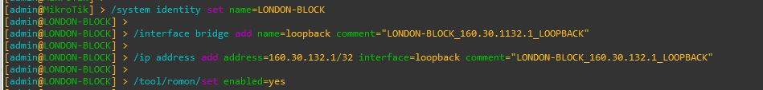

Figure 1: Set Identity, Loopback Address and RoMoN of LONDON_BLOCK Router Through CMD

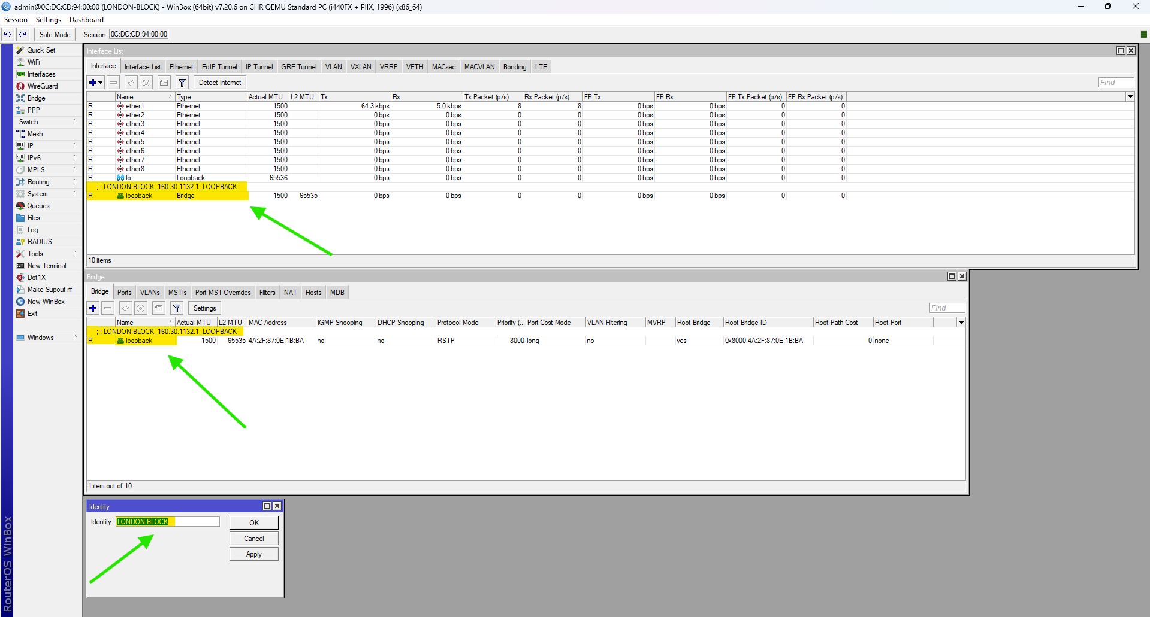

Figure 2: Set Identity, Loopback Address and RoMoN of LONDON_BLOCK Router Through WINBOX

## UK-BLOCK

**CMD**

|  |
| --- |
| /system identity set name= UK-BLOCK  /interface bridge add name=loopback comment=" UK-BLOCK_160.30.132.11_LOOPBACK"  /ip address add address=160.30.132.11/32 interface=loopback comment=" UK-BLOCK_160.30.132.11_LOOPBACK"  /tool/romon/set enabled=yes |

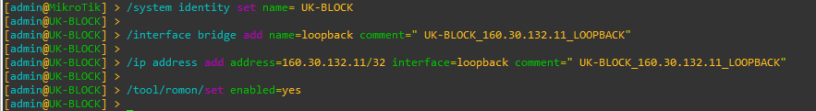

Figure 3: Set Identity, Loopback Address and RoMoN of UK-BLOCK Router Through CMD

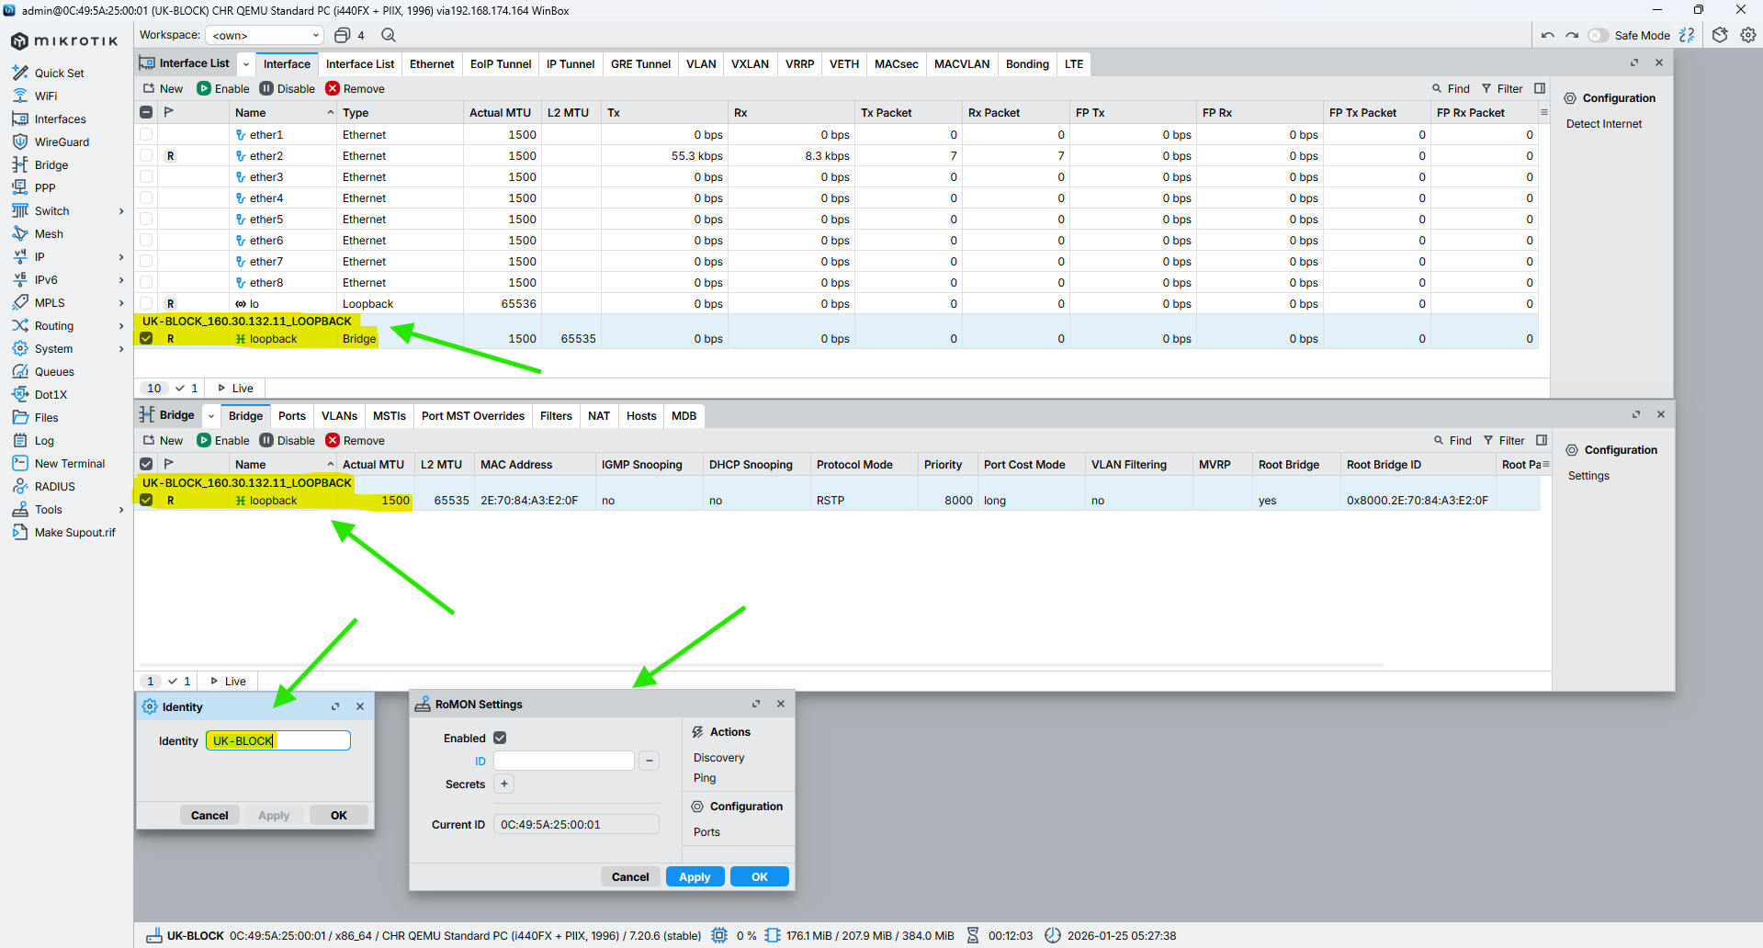

Figure 4: Set Identity, Loopback Address and RoMoN of UK-BLOCK Router Through WINBOX

## NEPAL-BLOCK

**CMD**

|  |
| --- |
| /system identity set name=NEPAL-BLOCK  /interface bridge add name=loopback comment="NEPAL-BLOCK_160.30.132.12_LOOPBACK"  /ip address add address=160.30.132.12/32 interface=loopback comment="NEPAL-BLOCK_160.30.132.12_LOOPBACK"  /tool/romon/set enabled=yes |

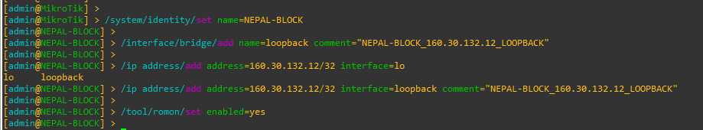

Figure 5: Set Identity, Loopback Address and RoMoN of NEPAL-BLOCK Router Through CMD

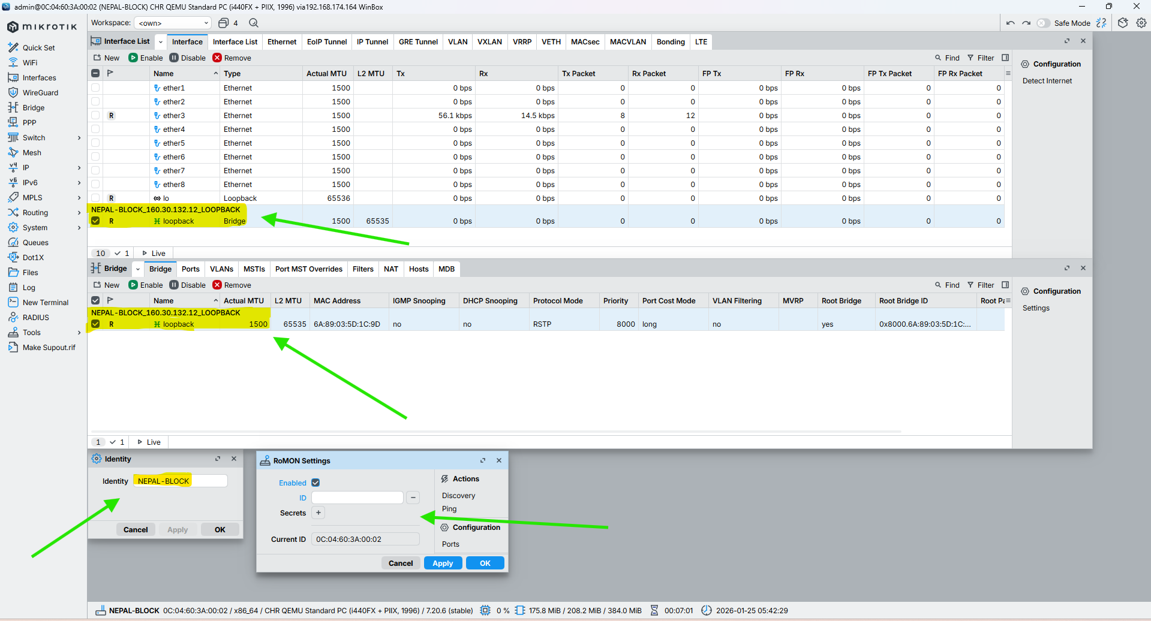

Figure 6: Set Identity, Loopback Address and RoMoN of NEPAL-BLOCK Router Through WINBOX

## HIMAL-BLOCK

**CMD**

|  |
| --- |
| /system identity set name=HIMAL-BLOCK  /interface bridge add name=loopback comment="HIMAL-BLOCK_160.30.132.13_LOOPBACK"  /ip address add address=160.30.132.13/32 interface=loopback comment="HIMAL-BLOCK_160.30.132.13_LOOPBACK"  /tool/romon/set enabled=yes |

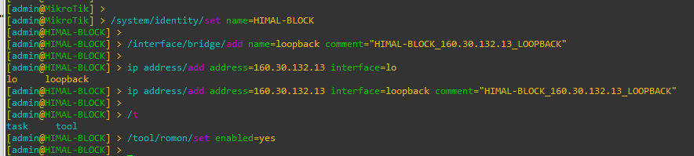

Figure 7: Set Identity, Loopback Address and RoMoN of NEPAL-BLOCK Router Through CMD

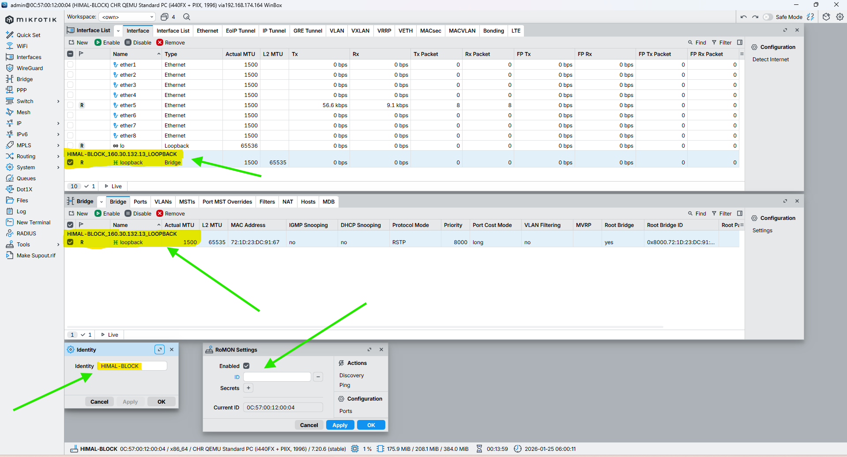

Figure 8: Set Identity, Loopback Address and RoMoN of NEPAL-BLOCK Router Through WINBOX

## BRIT-BLOCK

**CMD**

|  |
| --- |
| /system identity set name=BRIT-BLOCK  /interface bridge add name=loopback comment="BRIT-BLOCK_160.30.132.14_LOOPBACK"  /ip address add address=160.30.132.14/32 interface=loopback comment="BRIT-BLOCK_160.30.132.14_LOOPBACK"  /tool/romon/set enabled=yes |

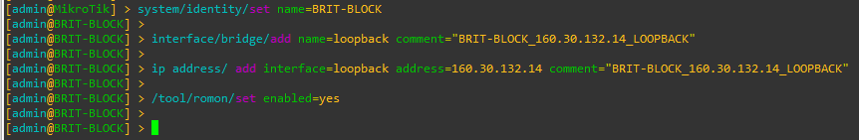

Figure 9: Set Identity, Loopback Address and RoMoN of BRIT-BLOCK Router Through CMD

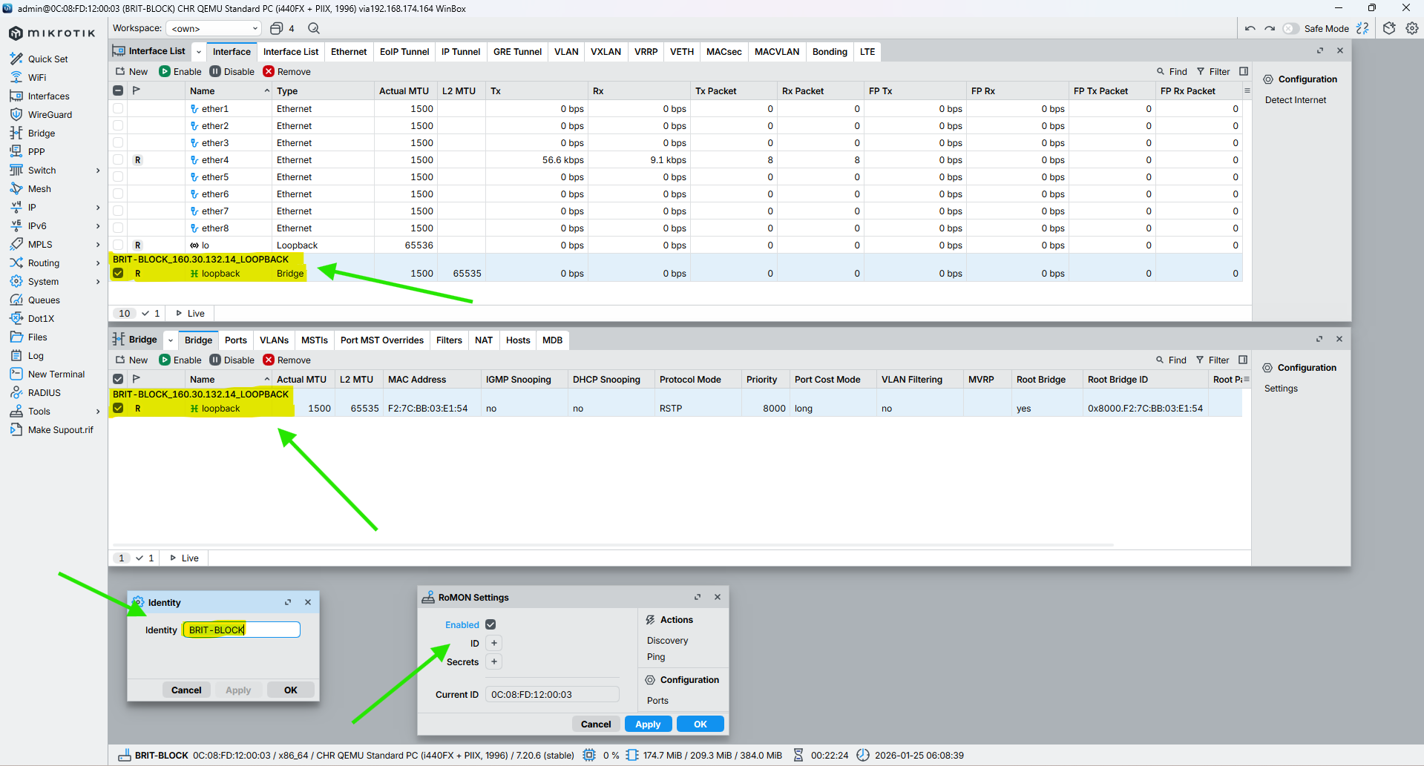

Figure 10: Set Identity, Loopback Address and RoMoN of BRIT-BLOCK Router Through WINBOX

## SKILL-BLOCK

**CMD**

|  |
| --- |
| /system identity set name=SKILL-BLOCK  /interface bridge add name=loopback comment="SKILL-BLOCK_160.30.132.15_LOOPBACK"  /ip address add address=160.30.132.15/32 interface=loopback comment="SKILL-BLOCK_160.30.132.15_LOOPBACK"  /tool/romon/set enabled=yes |

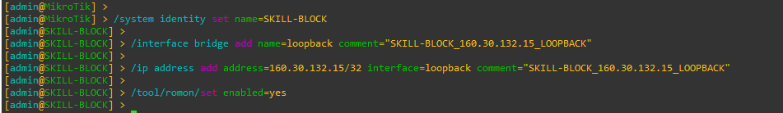

Figure 11: Set Identity, Loopback Address and RoMoN of SKILL-BLOCK Router Through CMD

Figure 12: Set Identity, Loopback Address and RoMoN of SKILL-BLOCK Router Through WINBOX

## ALUMNI-BLOCK

**CMD**

|  |
| --- |
| /system identity set name=ALUMNI-BLOCK  /interface bridge add name=loopback comment="ALUMNI-BLOCK_160.30.132.16_LOOPBACK"  /ip address add address=160.30.132.16/32 interface=loopback comment="ALUMNI-BLOCK_160.30.132.16_LOOPBACK"  /tool/romon/set enabled=yes |

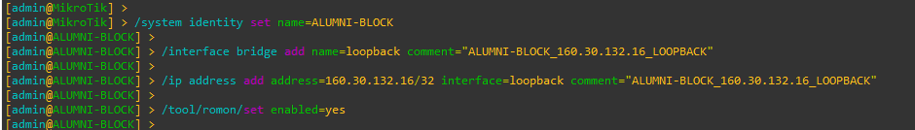

Figure 13: Set Identity, Loopback Address and RoMoN of ALUMNI-BLOCK Router Through CMD

Figure 14: Set Identity, Loopback Address and RoMoN of ALUMNI-BLOCK Router Through WINBOX

## KUMARI-BLOCK

**CMD**

|  |
| --- |
| /system identity set name=KUMARI-BLOCK  /interface bridge add name=loopback comment="KUMARI-BLOCK_160.30.132.17_LOOPBACK"  /ip address add address=160.30.132.17/32 interface=loopback comment="KUMARI-BLOCK_160.30.132.17_LOOPBACK"  /tool/romon/set enabled=yes |

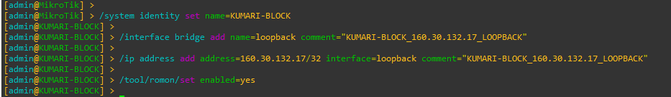

Figure 15: Set Identity, Loopback Address and RoMoN of KUMARI-BLOCK Router Through CMD

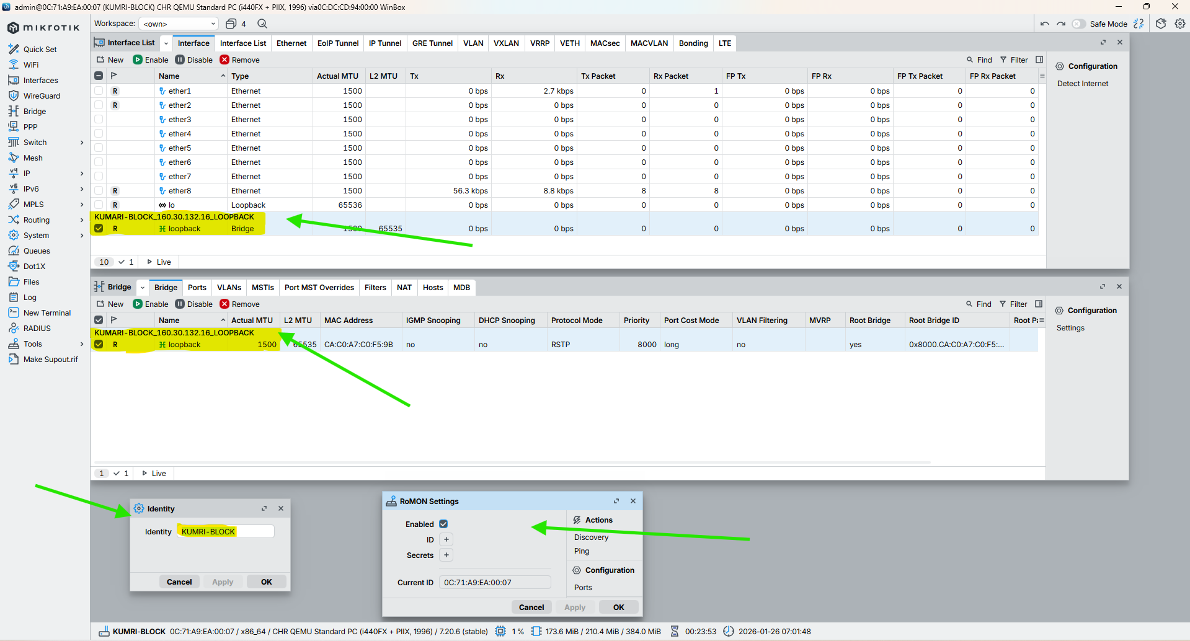

Figure 16: Set Identity, Loopback Address and RoMoN of KUMARI-BLOCK Router Through WINBOX

# Configuration IP in the Core Interface of all Routers

## LONDON-BLOCK

**CMD**

|  |
| --- |
| /ip address add address=10.0.0.1/30 interface=ether2 comment="NETWORK-ID_10.0.0.0/30_LINK_FROM_LONDON-BLOCK_10.0.0.1/30_TO_UK-BLOCK_10.0.0.2/30"  /ip address add address=10.0.0.5/30 interface=ether3 comment="NETWORK-ID_10.0.0.4/30_LINK_FROM_LONDON-BLOCK_10.0.0.5/30_TO_NEPAL-BLOCK_10.0.0.6/30"  /ip address add address=10.0.0.9/30 interface=ether4 comment="NETWORK-ID_10.0.0.8/30_LINK_FROM_LONDON-BLOCK_10.0.0.9/30_TO_HIMAL-BLOCK_10.0.0.10/30"  /ip address add address=10.0.0.13/30 interface=ether5 comment="NETWORK-ID_10.0.0.12/30_LINK_FROM_LONDON-BLOCK_10.0.0.13/30_TO_BRIT-BLOCK_10.0.0.14/30"  /ip address add address=10.0.0.17/30 interface=ether6 comment="NETWORK-ID_10.0.0.16/30_LINK_FROM_LONDON-BLOCK_10.0.0.17/30_TO_SKILL-BLOCK_10.0.0.18/30"  /ip address add address=10.0.0.21/30 interface=ether7 comment="NETWORK-ID_10.0.0.20/30_LINK_FROM_LONDON-BLOCK_10.0.0.21/30_TO_ALUMNI-BLOCK_10.0.0.22/30"  /ip address add address=10.0.0.25/30 interface=ether8 comment="NETWORK-ID_10.0.0.24/30_LINK_FROM_LONDON-BLOCK_10.0.0.25/30_TO_KUMARI-BLOCK_10.0.0.26/30" |

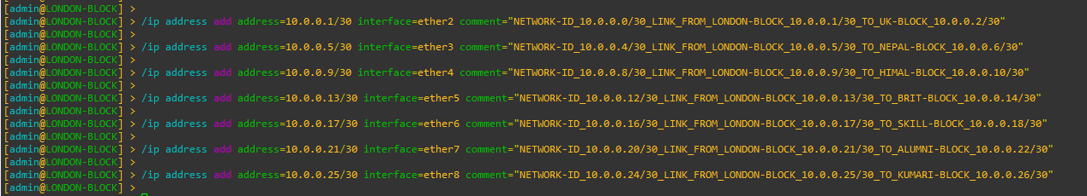

Figure 17: Configuration IP in the Core Interface of LONDON-BLOCK Router Through CMD

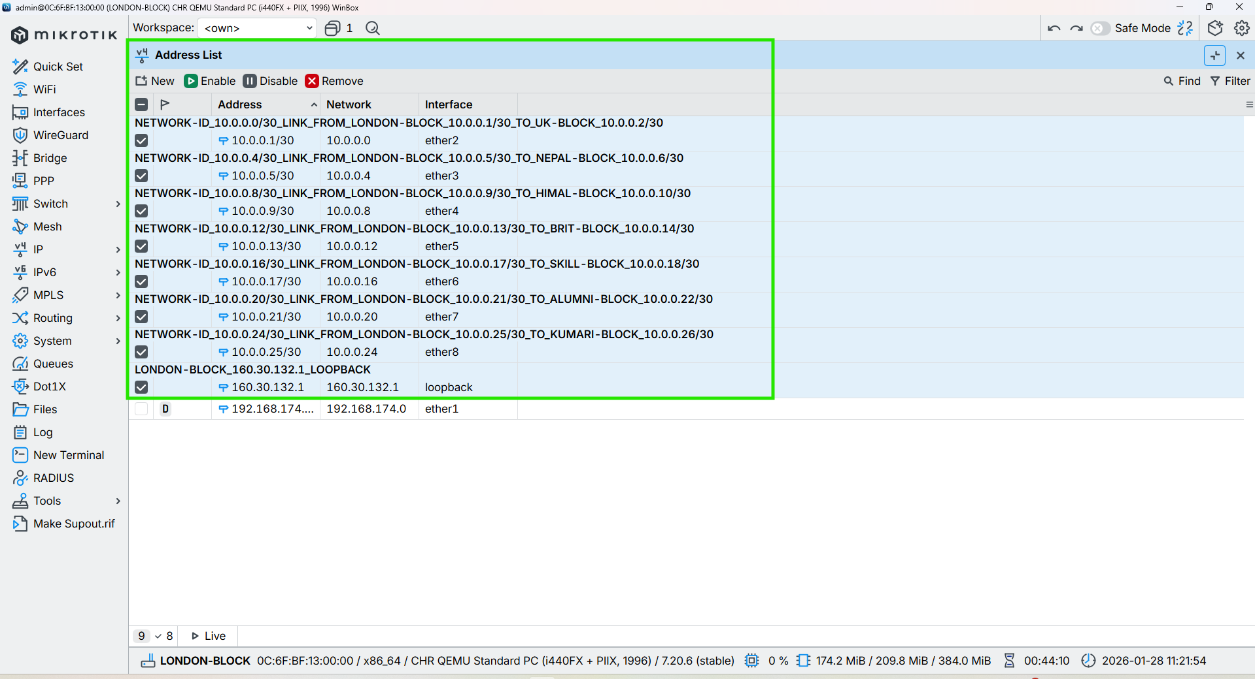

Figure 18: Configuration IP in the Core Interface of LONDON-BLOCK Router Through WINBOX

## UK-BLOCK

**CMD**

|  |
| --- |
| /ip address add address=10.0.0.2/30 interface=ether2 comment="NETWORK-ID_10.0.0.0/30_LINK_FROM_UK-BLOCK_10.0.0.2/30_TO_LONDON-BLOCK_10.0.0.1/30"  /ip address add address=10.0.0.29/30 interface=ether1 comment="NETWORK-ID_10.0.0.28/30_LINK_FROM_UK-BLOCK_10.0.0.29/30_TO_NEPAL-BLOCK_10.0.0.30/30"  /ip address add address=10.0.0.34/30 interface=ether3 comment="NETWORK-ID_10.0.0.32/30_LINK_FROM_UK-BLOCK_10.0.0.34/30_TO_HIMAL-BLOCK_10.0.0.33/30" |



Figure 19: Configuration IP in the Core Interface of UK-BLOCK Router Through CMD

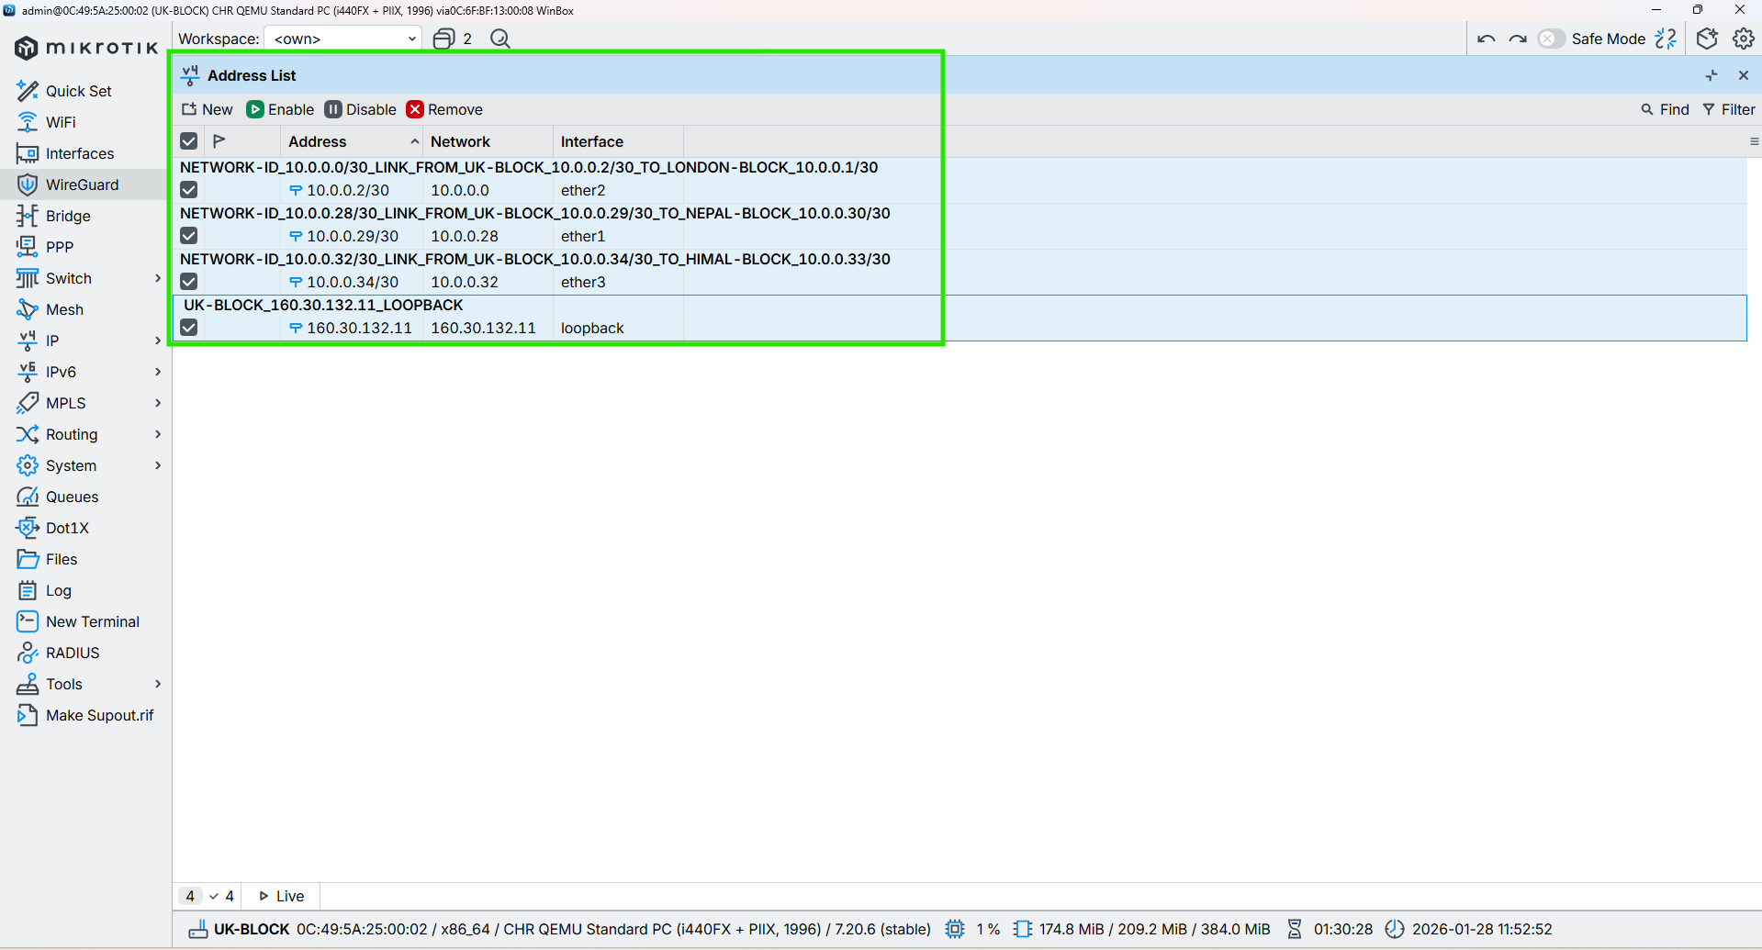

Figure 20: Configuration IP in the Core Interface of UK-BLOCK Router Through WINBOX

## NEPAL-BLOCK

**CMD**

|  |
| --- |
| /ip address add address=10.0.0.6/30 interface=ether3 comment="NETWORK-ID_10.0.0.4/30_LINK_FROM_NEPAL-BLOCK_10.0.0.6/30_TO_LONDON-BLOCK_10.0.0.5/30"  /ip address add address=10.0.0.30/30 interface=ether1 comment="NETWORK-ID_10.0.0.28/30_LINK_FROM_NEPAL-BLOCK_10.0.0.30/30_TO_UK-BLOCK_10.0.0.29/30"  /ip address add address=10.0.0.37/30 interface=ether2 comment="NETWORK-ID_10.0.0.36/30_LINK_FROM_NEPAL-BLOCK_10.0.0.37/30_TO_BRIT-BLOCK_10.0.0.38/30" |



Figure 21: Configuration IP in the Core Interface of NEPAL-BLOCK Router Through CMD

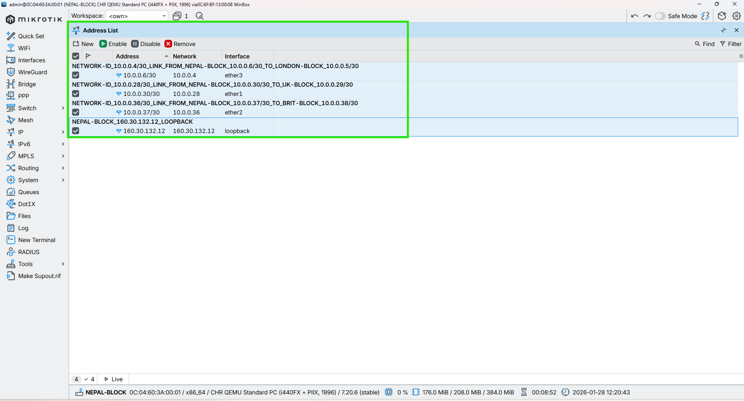

Figure 22: Configuration IP in the Core Interface of NEPAL-BLOCK Router Through WINBOX

## HIMAL-BLOCK

**CMD**

|  |
| --- |
| /ip address add address=10.0.0.33/30 interface=ether3 comment="NETWORK-ID_10.0.0.32/30_LINK_FROM_HIMAL-BLOCK_10.0.0.33/30_TO_UK-BLOCK_10.0.0.34/30"  /ip address add address=10.0.0.10/30 interface=ether4 comment="NETWORK-ID_10.0.0.8/30_LINK_FROM_HIMAL-BLOCK_10.0.0.10/30_TO_LONDON-BLOCK_10.0.0.9/30"  /ip address add address=10.0.0.42/30 interface=ether2 comment="NETWORK-ID_10.0.0.40/30_LINK_FROM_HIMAL-BLOCK_10.0.0.42/30_TO_SKILL-BLOCK_10.0.0.41/30"c |



Figure 23: Configuration IP in the Core Interface of HIMAL-BLOCK Router Through CMD

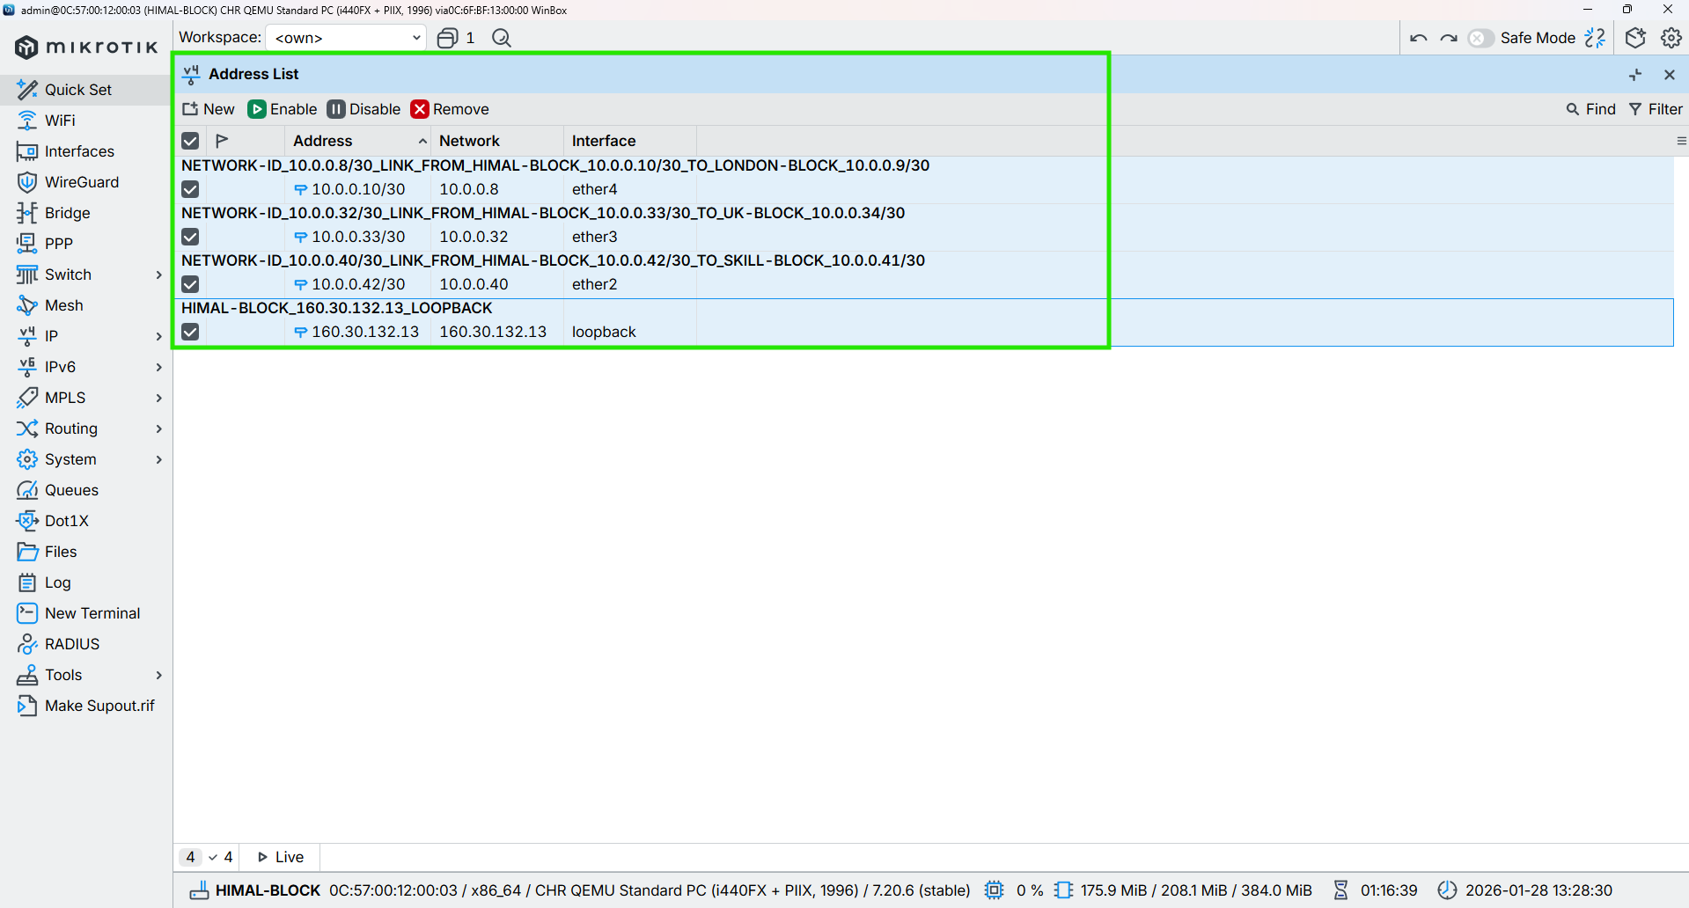

Figure 24: Configuration IP in the Core Interface of HIMAL-BLOCK Router Through WINBOX

## BRIT-BLOCK

**CMD**

|  |
| --- |
| /ip address add address=10.0.0.38/30 interface=ether2 comment="NETWORK-ID_10.0.0.36/30_LINK_FROM_BRIT-BLOCK_10.0.0.38/30_TO_NEPAL-BLOCK_10.0.0.37/30"  /ip address add address=10.0.0.14/30 interface=ether5 comment="NETWORK-ID_10.0.0.12/30_LINK_FROM_BRIT-BLOCK_10.0.0.14/30_TO_LONDON-BLOCK_10.0.0.13/30"  /ip address add address=10.0.0.46/30 interface=ether1 comment="NETWORK-ID_10.0.0.44/30_LINK_FROM_BRIT-BLOCK_10.0.0.46/30_TO_KUMARI-BLOCK_10.0.0.45/30" |



Figure 25: Configuration IP in the Core Interface of BRIT-BLOCK Router Through CMD

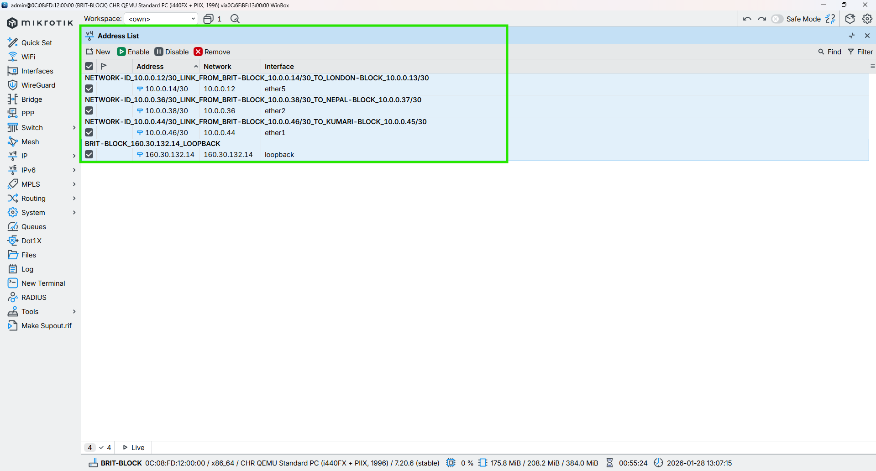

Figure 26: Configuration IP in the Core Interface of BRIT-BLOCK Router Through WINBOX

## SKILL-BLOCK

**CMD**

|  |
| --- |
| /ip address add address=10.0.0.41/30 interface=ether2 comment=”NETWORK-ID_10.0.0.40/30_LINK_FROM_SKILL-BLOCK_10.0.0.41/30_TO_NEPAL-BLOCK_10.0.0.42/30”  /ip address add address=10.0.0.18/30 interface=ether6 comment=”NETWORK-ID_10.0.0.16/30_LINK_FROM_SKILL-BLOCK_10.0.0.18/30_TO_LONDON-BLOCK_10.0.0.17/30”  /ip address add address=10.0.0.50/30 interface=ether1 comment=”NETWORK-ID_10.0.0.48/30_LINK_FROM_SKILL-BLOCK_10.0.0.50/30_TO_KUMARI-BLOCK_10.0.0.49/30” |



Figure 27: Configuration IP in the Core Interface of SKILL-BLOCK Router Through CMD

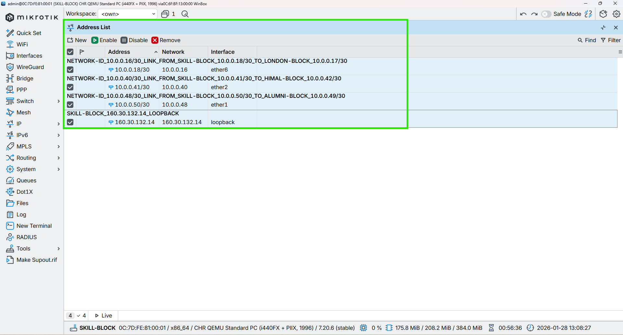

Figure 28: Configuration IP in the Core Interface of SKILL-BLOCK Router Through WINBOX

## ALUMNI-BLOCK

**CMD**

|  |
| --- |
| /ip address add address=10.0.0.22/30 interface=ether7 comment="NETWORK-ID_10.0.0.20/30_LINK_FROM_ALUMNI-BLOCK_10.0.0.22/30_TO_LONDON-BLOCK_10.0.0.21/30"  /ip address add address=10.0.0.49/30 interface=ether1 comment="NETWORK-ID_10.0.0.48/30_LINK_FROM_ALUMNI-BLOCK_10.0.0.49/30_TO_SKILL-BLOCK_10.0.0.50/30"  /ip address add address=10.0.0.53/30 interface=ether2 comment="NETWORK-ID_10.0.0.52/30_LINK_FROM_ALUMNI-BLOCK_10.0.0.53/30_TO_KUMARI-BLOCK_10.0.0.54/30" |

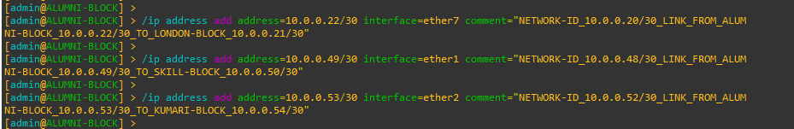

Figure 29: Configuration IP in the Core Interface of ALUMNI-BLOCK Router Through CMD

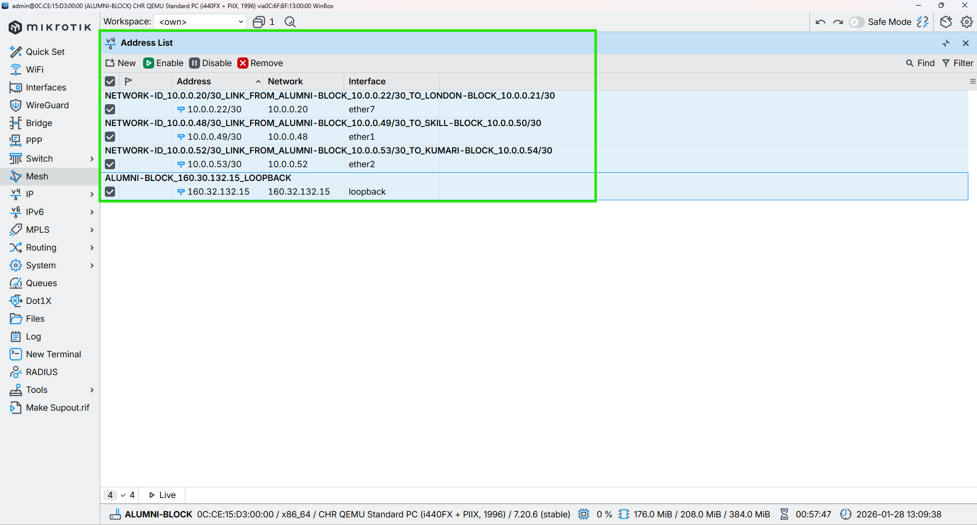

Figure 30: Configuration IP in the Core Interface of ALUMNI-BLOCK Router Through WINBOX

## KUMARI-BLOCK

**CMD**

|  |
| --- |
| /ip address add address=10.0.0.26/30 interface=ether8 comment="NETWORK-ID_10.0.0.24/30_LINK_FROM_KUMARI-BLOCK_10.0.0.26/30_TO_LONDON-BLOCK_10.0.0.25/30"  /ip address add address=10.0.0.54/30 interface=ether2 comment="NETWORK-ID_10.0.0.52/30_LINK_FROM_KUMARI-BLOCK_10.0.0.54/30_TO_ALUMNI-BLOCK_10.0.0.53/30"  /ip address add address=10.0.0.44/30 interface=ether1 comment="NETWORK-ID_10.0.0.44/30_LINK_FROM_KUMARI-BLOCK_10.0.0.44/30_TO_BRIT-BLOCK_10.0.0.46/30" |



Figure 31: Configuration IP in the Core Interface of KUMARI-BLOCK Router Through CMD

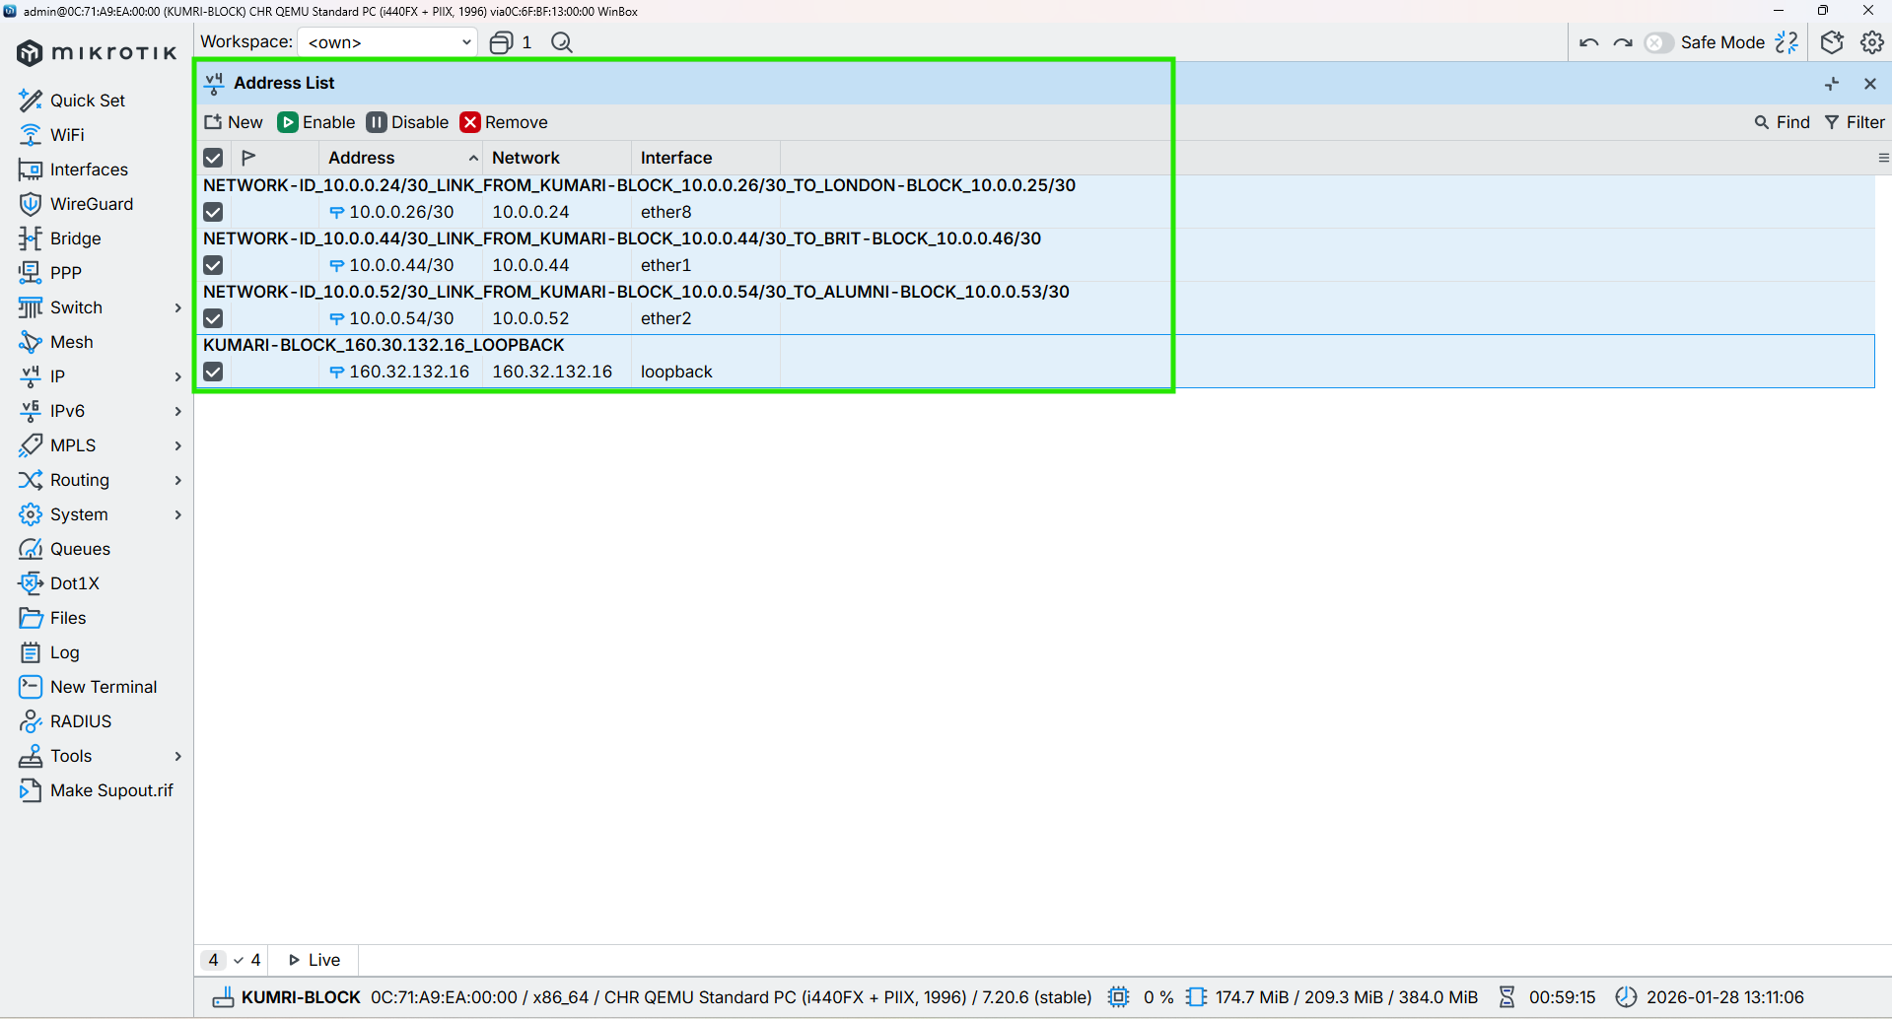

Figure 32: Configuration IP in the Core Interface of KUMARI-BLOCK Router Through WINBOX

# Configuration OSPF to all Core Routers

## LONDON-BLOCK

CMD

|  |
| --- |
| /routing ospf instance add name=OSPF_LONDON_BLOCK router-id=160.30.132.1 comment="OSPF instance for London block, router-id 160.30.132.1"  /routing ospf area add name=backbone area-id=0.0.0.0 instance=OSPF_LONDON_BLOCK comment="Backbone area 0.0.0.0 for London OSPF"  /routing ospf interface-template  add interfaces=loopback area=backbone passive comment="Loopback London router-id 160.30.132.1 (passive)"  add networks=10.0.0.0/30 interfaces=ether2 area=backbone comment="ETHER-2_LINK_FROM_LONDON-BLOCK_10.0.0.1_TO_UK-BLOCK_10.0.0.2"  add networks=10.0.0.4/30 interfaces=ether3 area=backbone comment="ETHER-3_LINK_FROM_LONDON-BLOCK_10.0.0.5_TO_NEPAL-BLOCK_10.0.0.6"  add networks=10.0.0.8/30 interfaces=ether4 area=backbone comment="ETHER-4_LINK_FROM_LONDON-BLOCK_10.0.0.9_TO_HIMAL-BLOCK_10.0.0.10"  add networks=10.0.0.12/30 interfaces=ether5 area=backbone comment="ETHER-5_LINK_FROM_LONDON-BLOCK_10.0.0.13_TO_BRIT-BLOCK_10.0.0.14"  add networks=10.0.0.16/30 interfaces=ether6 area=backbone comment="ETHER-6_LINK_FROM_LONDON-BLOCK_10.0.0.17_TO_SKILL-BLOCK_10.0.0.18"  add networks=10.0.0.20/30 interfaces=ether7 area=backbone comment="ETHER-7_LINK_FROM_LONDON-BLOCK_10.0.0.21_TO_ALUMNI-BLOCK_10.0.0.22"  add networks=10.0.0.24/30 interfaces=ether8 area=backbone comment="ETHER-8_LINK_FROM_LONDON-BLOCK_10.0.0.25_TO_KUMARI-BLOCK_10.0.0.26" |

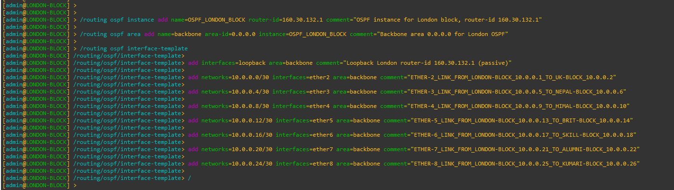

Figure 33: Configuration OSPF to Core LONDON-BLOCK Router Through CMD

|  |
| --- |
| Figure 34: Configuration OSPF Instances to Core LONDON-BLOCK Router Through WINBOX |
| Figure 35: Configuration OSPF Area to Core LONDON-BLOCK Router Through WINBOX |
| Figure 36: Configuration OSPF Interface-template to Core LONDON-BLOCK Router Through WINBOX |

## UK-BLOCK

CMD

|  |
| --- |
| /routing ospf instance add name=OSPF_UK_BLOCK router-id=160.30.132.11 comment="OSPF instance for UK block, router-id 160.30.132.11"  /routing ospf area add name=backbone area-id=0.0.0.0 instance=OSPF_UK_BLOCK comment="Backbone area 0.0.0.0 for UK OSPF"  /routing ospf interface-template  add interfaces=loopback area=backbone comment="Loopback UK router-id 160.30.132.11 (passive)"  add networks=10.0.0.0/30 interfaces=ether2 area=backbone comment="ETHER-2_LINK_FROM_UK-BLOCK_10.0.0.2_TO_LONDON-BLOCK_10.0.0.1"  add networks=10.0.0.28/30 interfaces=ether1 area=backbone comment="ETHER-3_LINK_FROM_UK-BLOCK_10.0.0.29_TO_NEPAL-BLOCK_10.0.0.30"  add networks=10.0.0.32/30 interfaces=ether3 area=backbone comment="ETHER-3_LINK_FROM_UK-BLOCK_10.0.0.34_TO_HIMAL-BLOCK_10.0.0.33" |

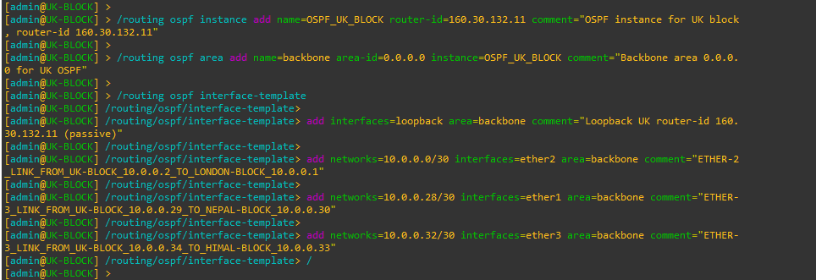

Figure 37: Configuration OSPF to UK-BLOCK Router Through CMD

|  |
| --- |
| Figure 38: Configuration OSPF Instances to UK-BLOCK Router Through WINBOX |
| Figure 39: Configuration OSPF Area to UK-BLOCK Router Through WINBOX |
| Figure 40: Configuration OSPF Interface-template to UK-BLOCK Router Through WINBOX |

## NEPAL-BLOCK

**CMD**

|  |
| --- |
| /routing ospf instance add name=OSPF_NEPAL_BLOCK router-id=160.30.132.12 comment="OSPF instance for NEPAL block, router-id 160.30.132.12"  /routing ospf area add name=backbone area-id=0.0.0.0 instance=OSPF_NEPAL_BLOCK comment="Backbone area 0.0.0.0 for NEPAL OSPF"  /routing ospf interface-template  add interfaces=loopback area=backbone comment="Loopback NEPAL router-id 160.30.132.12 (passive)"  add networks=10.0.0.28/30 interfaces=ether1 area=backbone comment="ETHER-1_LINK_FROM_NEPAL-BLOCK_10.0.0.30_TO_UK-BLOCK_10.0.0.29"  add networks=10.0.0.4/30 interfaces=ether3 area=backbone comment="ETHER-3_LINK_FROM_NEPAL-BLOCK_10.0.0.6_TO_LONDON-BLOCK_10.0.0.5"  add networks=10.0.0.36/30 interfaces=ether2 area=backbone comment="ETHER-2_LINK_FROM_NEPAL-BLOCK_10.0.0.37_TO_BRIT-BLOCK_10.0.0.38" |

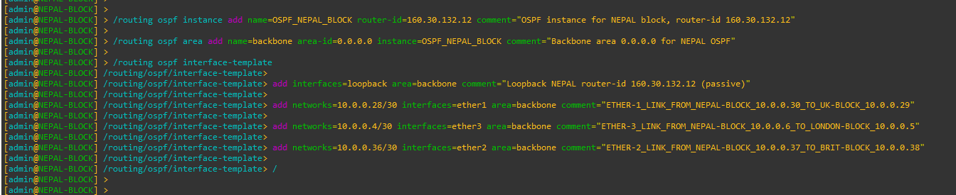

Figure 41: Configuration OSPF to NEPAL-BLOCK Router Through CMD

|  |
| --- |
| Figure 42: Configuration OSPF Instances to NEPAL-BLOCK Router Through WINBOX |
| Figure 43: Configuration OSPF Area to NEPAL-BLOCK Router Through WINBOX |
| Figure 44: Configuration OSPF Interface-template to NEPAL-BLOCK Router Through WINBOX |

## HIMAL-BLOCK

CMD

|  |
| --- |
| /routing ospf instance add name=OSPF_HIMAL_BLOCK router-id=160.30.132.13 comment="OSPF instance for HIMAL block, router-id 160.30.132.13"  /routing ospf area add name=backbone area-id=0.0.0.0 instance=OSPF_HIMAL_BLOCK comment="Backbone area 0.0.0.0 for HIMAL OSPF"  /routing ospf interface-template  add interfaces=loopback area=backbone comment="Loopback HIMAL router-id 160.30.132.13 (passive)"  add networks=10.0.0.32/30 interfaces=ether3 area=backbone comment="ETHER-3_LINK_FROM_HIMAL-BLOCK_10.0.0.33_TO_UK-BLOCK_10.0.0.34"  add networks=10.0.0.8/30 interfaces=ether4 area=backbone comment="ETHER-4_LINK_FROM_HIMAL-BLOCK_10.0.0.10_TO_LONDON-BLOCK_10.0.0.9"  add networks=10.0.0.40/30 interfaces=ether2 area=backbone comment="ETHER-2_LINK_FROM_HIMAL-BLOCK_10.0.0.42_TO_SKILL-BLOCK_10.0.0.41" |

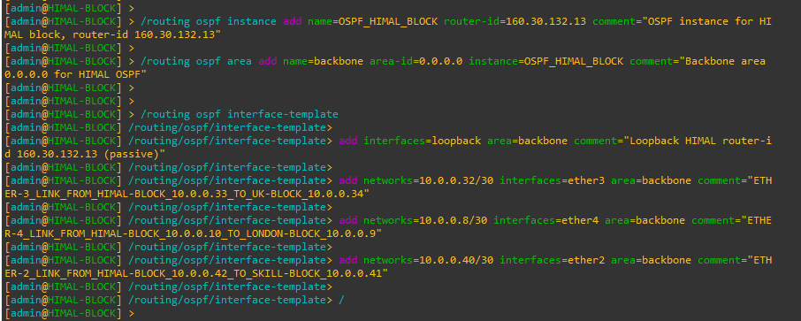

Figure 45: Configuration OSPF to HIMAL-BLOCK Router Through CMD

|  |
| --- |
| Figure 46: Configuration OSPF Instances to HIMAL-BLOCK Router Through WINBOX |
| Figure 47: Configuration OSPF Area to HIMAL-BLOCK Router Through WINBOX |
| Figure 48: Configuration OSPF Interface-template to HIMAL-BLOCK Router Through WINBOX |

## BRIT-BLOCK

**CMD**

|  |
| --- |
| /routing ospf instance add name=OSPF_BRIT_BLOCK router-id=160.30.132.14 comment="OSPF instance for BRIT block, router-id 160.30.132.14"  /routing ospf area add name=backbone area-id=0.0.0.0 instance=OSPF_BRIT_BLOCK comment="Backbone area 0.0.0.0 for BRIT OSPF"  /routing ospf interface-template  add interfaces=loopback area=backbone comment="Loopback BRIT router-id 160.30.132.14 (passive)"  add networks=10.0.0.36/30 interfaces=ether2 area=backbone comment="ETHER-2_LINK_FROM_BRIT-BLOCK_10.0.0.38_TO_NEPAL-BLOCK_10.0.0.37"  add networks=10.0.0.12/30 interfaces=ether5 area=backbone comment="ETHER-5_LINK_FROM_BRIT-BLOCK_10.0.0.14_TO_LONDON-BLOCK_10.0.0.13"  add networks=10.0.0.44/30 interfaces=ether1 area=backbone comment="ETHER-1_LINK_FROM_BRIT-BLOCK_10.0.0.46_TO_SKILL-BLOCK_10.0.0.45" |

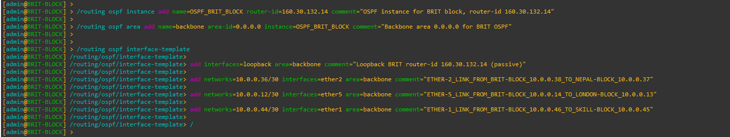

Figure 49: Configuration OSPF to BRIT-BLOCK Router Through CMD

|  |
| --- |
| Figure 50: Configuration OSPF Instances to BRIT-BLOCK Router Through WINBOX |
| Figure 51: Configuration OSPF Area to BRIT-BLOCK Router Through WINBOX |
| Figure 52: Configuration OSPF Interface-template to BRIT-BLOCK Router Through WINBOX |

## SKILL-BLOCK

CMD

|  |
| --- |
| /routing ospf instance add name=OSPF_SKILL_BLOCK router-id=160.30.132.15 comment="OSPF instance for SKILL block, router-id 160.30.132.15"  /routing ospf area add name=backbone area-id=0.0.0.0 instance=OSPF_SKILL_BLOCK comment="Backbone area 0.0.0.0 for SKILL OSPF"  /routing ospf interface-template  add interfaces=loopback area=backbone comment="Loopback SKILL router-id 160.30.132.15 (passive)"  add networks=10.0.0.40/30 interfaces=ether2 area=backbone comment="ETHER-2_LINK_FROM_SKILL-BLOCK_10.0.0.41_TO_HIMAL-BLOCK_10.0.0.42"  add networks=10.0.0.16/30 interfaces=ether6 area=backbone comment="ETHER-6_LINK_FROM_SKILL-BLOCK_10.0.0.18_TO_LONDON-BLOCK_10.0.0.17"  add networks=10.0.0.48/30 interfaces=ether1 area=backbone comment="ETHER-1_LINK_FROM_SKILL-BLOCK_10.0.0.50_TO_ALUMNI-BLOCK_10.0.0.49" |

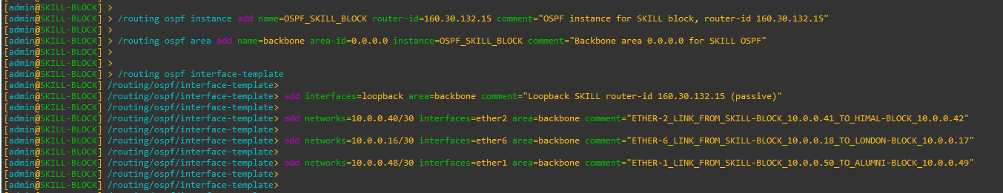

Figure 53: Configuration OSPF to SKILL-BLOCK Router Through CMD

|  |
| --- |
| Figure 54: Configuration OSPF Instances to SKILL-BLOCK Router Through WINBOX |
| Figure 55: Configuration OSPF Area to SKILL-BLOCK Router Through WINBOX |
| Figure 56: Configuration OSPF Interface-template to SKILL-BLOCK Router Through WINBOX |

## ALUMNI-BLOCK

CMD

|  |
| --- |
| /routing ospf instance add name=OSPF_ALUMNI_BLOCK router-id=160.30.132.16 comment="OSPF instance for ALUMNI block, router-id 160.30.132.16"  /routing ospf area add name=backbone area-id=0.0.0.0 instance=OSPF_ALUMNI_BLOCK comment="Backbone area 0.0.0.0 for ALUMNI OSPF"  /routing ospf interface-template  add interfaces=loopback area=backbone comment="Loopback ALUMNI router-id 160.30.132.16 (passive)"  add networks=10.0.0.48/30 interfaces=ether1 area=backbone comment="ETHER-1_LINK_FROM_ALUMNI-BLOCK_10.0.0.49_TO_SKILL-BLOCK_10.0.0.50"  add networks=10.0.0.20/30 interfaces=ether7 area=backbone comment="ETHER-7_LINK_FROM_ALUMNI-BLOCK_10.0.0.22_TO_LONDON-BLOCK_10.0.0.21"  add networks=10.0.0.52/30 interfaces=ether2 area=backbone comment="ETHER-2_LINK_FROM_ALUMNI-BLOCK_10.0.0.53_TO_KUMARI-BLOCK_10.0.0.54" |

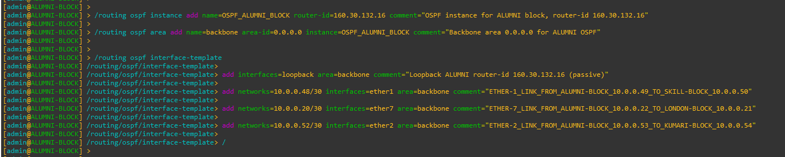

Figure 57: Configuration OSPF to ALUMNI-BLOCK Router Through CMD

|  |
| --- |
| Figure 58: Configuration OSPF Instances to ALUMNI-BLOCK Router Through WINBOX |
| Figure 59: Configuration OSPF Area to ALUMNI-BLOCK Router Through WINBOX |
| Figure 60: Configuration OSPF Interface-template to ALUMNI-BLOCK Router Through WINBOX |

## KUMARI-BLOCK

CMD

|  |
| --- |
| /routing ospf instance add name=OSPF_KUMARI_BLOCK router-id=160.30.132.17 comment="OSPF instance for KUMARI block, router-id 160.30.132.17"  /routing ospf area add name=backbone area-id=0.0.0.0 instance=OSPF_KUMARI_BLOCK comment="Backbone area 0.0.0.0 for KUMARI OSPF"  /routing ospf interface-template  add interfaces=loopback area=backbone comment="Loopback KUMARI router-id 160.30.132.17 (passive)"  add networks=10.0.0.44/30 interfaces=ether1 area=backbone comment="ETHER-1_LINK_FROM_KUMARI-BLOCK_10.0.0.45_TO_BRIT-BLOCK_10.0.0.46"  add networks=10.0.0.24/30 interfaces=ether8 area=backbone comment="ETHER-8_LINK_FROM_KUMARI-BLOCK_10.0.0.26_TO_LONDON-BLOCK_10.0.0.25"  add networks=10.0.0.52/30 interfaces=ether2 area=backbone comment="ETHER-2_LINK_FROM_KUMARI-BLOCK_10.0.0.54_TO_ALUMNI-BLOCK_10.0.0.53" |

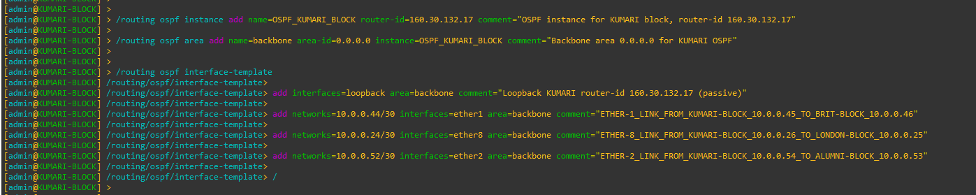

Figure 61: Configuration OSPF to KUMARI-BLOCK Router Through CMD

|  |
| --- |
| Figure 62: Configuration OSPF Instances to KUMARI-BLOCK Router Through WINBOX |
| Figure 63: Configuration OSPF Area to KUMARI-BLOCK Router Through WINBOX |
| Figure 64: Configuration OSPF Interface-template to KUMARI-BLOCK Router Through WINBOX |

# Configure Management Access from PC to MPLS Loopback

## PC (VMware Host) – Static Route Configuration

To allow the PC (VMware host) to reach the MPLS loopback network

160.30.132.0/24, a persistent static route is added on the PC pointing to the

LONDON-BLOCK management interface.

CMD (Windows PC)

|  |
| --- |
| route -p add 160.30.132.0 mask 255.255.255.0 192.168.174.173 |



## UK-BLOCK – OSPF Configuration (No Management Network Advertisement)

LONDON-BLOCK acts as the central management gateway between the PC and the MPLS core. UK-BLOCK participates only in MPLS core OSPF.

The VMware management network must not be added to OSPF.

|  |
| --- |
| /routing ospf interface-template  add networks=192.168.174.0/24 interfaces=ether9 area=backbone  / |



## Disable RoMON temporarily to avoid confusion

Cmd

|  |
| --- |
| /tool romon set enabled=no |

## End-to-End Verification (From PC)

Ping Test

|  |
| --- |
| ping 160.30.132.1  ping 160.30.132.11  ping 160.30.132.14  ping 160.30.132.16 |

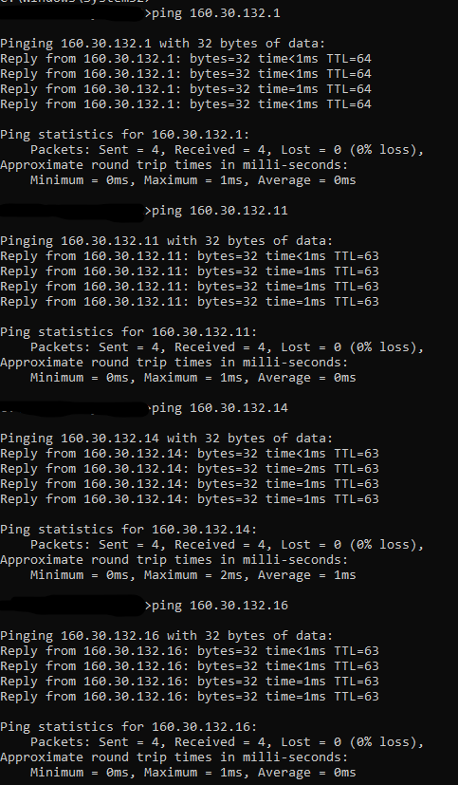

# Configuration MPLS to all Core Routers

## LONDON-BLOCK

## UK-BLOCK

## NEPAL-BLOCK

## HIMAL-BLOCK

## BRIT-BLOCK

## SKILL-BLOCK

## ALUMNI-BLOCK

## KUMARI-BLOCK

# Configuration LDP on Interfaces of Core Interfaces Routers

## LONDON-BLOCK

## UK-BLOCK

## NEPAL-BLOCK

## HIMAL-BLOCK

## BRIT-BLOCK

## SKILL-BLOCK

## ALUMNI-BLOCK

## KUMARI-BLOCK

# Set MPLS MTU (Crucial for VPLS to prevent fragmentation)

## LONDON-BLOCK

## UK-BLOCK

## NEPAL-BLOCK

## HIMAL-BLOCK

## BRIT-BLOCK

## SKILL-BLOCK

## ALUMNI-BLOCK

## KUMARI-BLOCK

# VPLS Setup (Points to Points) Routers

## LONDON-BLOCK

## UK-BLOCK

## NEPAL-BLOCK

## HIMAL-BLOCK

## BRIT-BLOCK

## SKILL-BLOCK

## ALUMNI-BLOCK

## KUMARI-BLOCK

# VPLS Configuration for VLAN Transport

## LONDON-BLOCK

## UK-BLOCK

## NEPAL-BLOCK

## HIMAL-BLOCK

## BRIT-BLOCK

## SKILL-BLOCK

## ALUMNI-BLOCK

## KUMARI-BLOCK

# Centralized DHCP Server Configuration

## LONDON-BLOCK

## UK-BLOCK

## NEPAL-BLOCK

## HIMAL-BLOCK

## BRIT-BLOCK

## SKILL-BLOCK

## ALUMNI-BLOCK

## KUMARI-BLOCK

# Redundancy and Load Balancing

## LONDON-BLOCK

## UK-BLOCK

## NEPAL-BLOCK

## HIMAL-BLOCK

## BRIT-BLOCK

## SKILL-BLOCK

## ALUMNI-BLOCK

## KUMARI-BLOCK

# End-to-End Verification and Traffic Analysis

## LONDON-BLOCK

## UK-BLOCK

## NEPAL-BLOCK

## HIMAL-BLOCK

## BRIT-BLOCK

## SKILL-BLOCK

## ALUMNI-BLOCK

## KUMARI-BLOCK

# Network Topology and Diagrams

## Full Network Topology Diagram

## MPLS LSP Paths Illustration

## VPLS VLAN Extension Diagram

# Troubleshooting Guide

## Common OSPF Issues

## MPLS / LDP Problems

## VPLS VLAN Bridging Errors

## DHCP Failures

## ECMP / Load Balancing Verification Tips

# Security and Access Control

## Management Access (SSH / Winbox)

## ACLs / Firewall Rules for Router Interfaces

# 

# Conclusion and Future Enhancements

# a